Used machine:
CPU: Ryzen 5 3600

Question 1: Maximum solvable problem size

At value n=36 the program starts taking longer than an hour to find a solution. And at value n= 41 it starts taking longer than a day. We can’t afford to let it run for longer than that, therefore we presume that for n>41 the problem can’t produce a solution. (in theory it can if we let the machine for long enough, which would be challenging in itself)

Question 2: Execution time results

Problem Size | 5 | 10 | 15 | 20 | 25 | 30 | 35
Time (seconds) | 0.014 | 0.014 | 0.18 | 0.78 | 2.168 | 62.719 | 2033.168

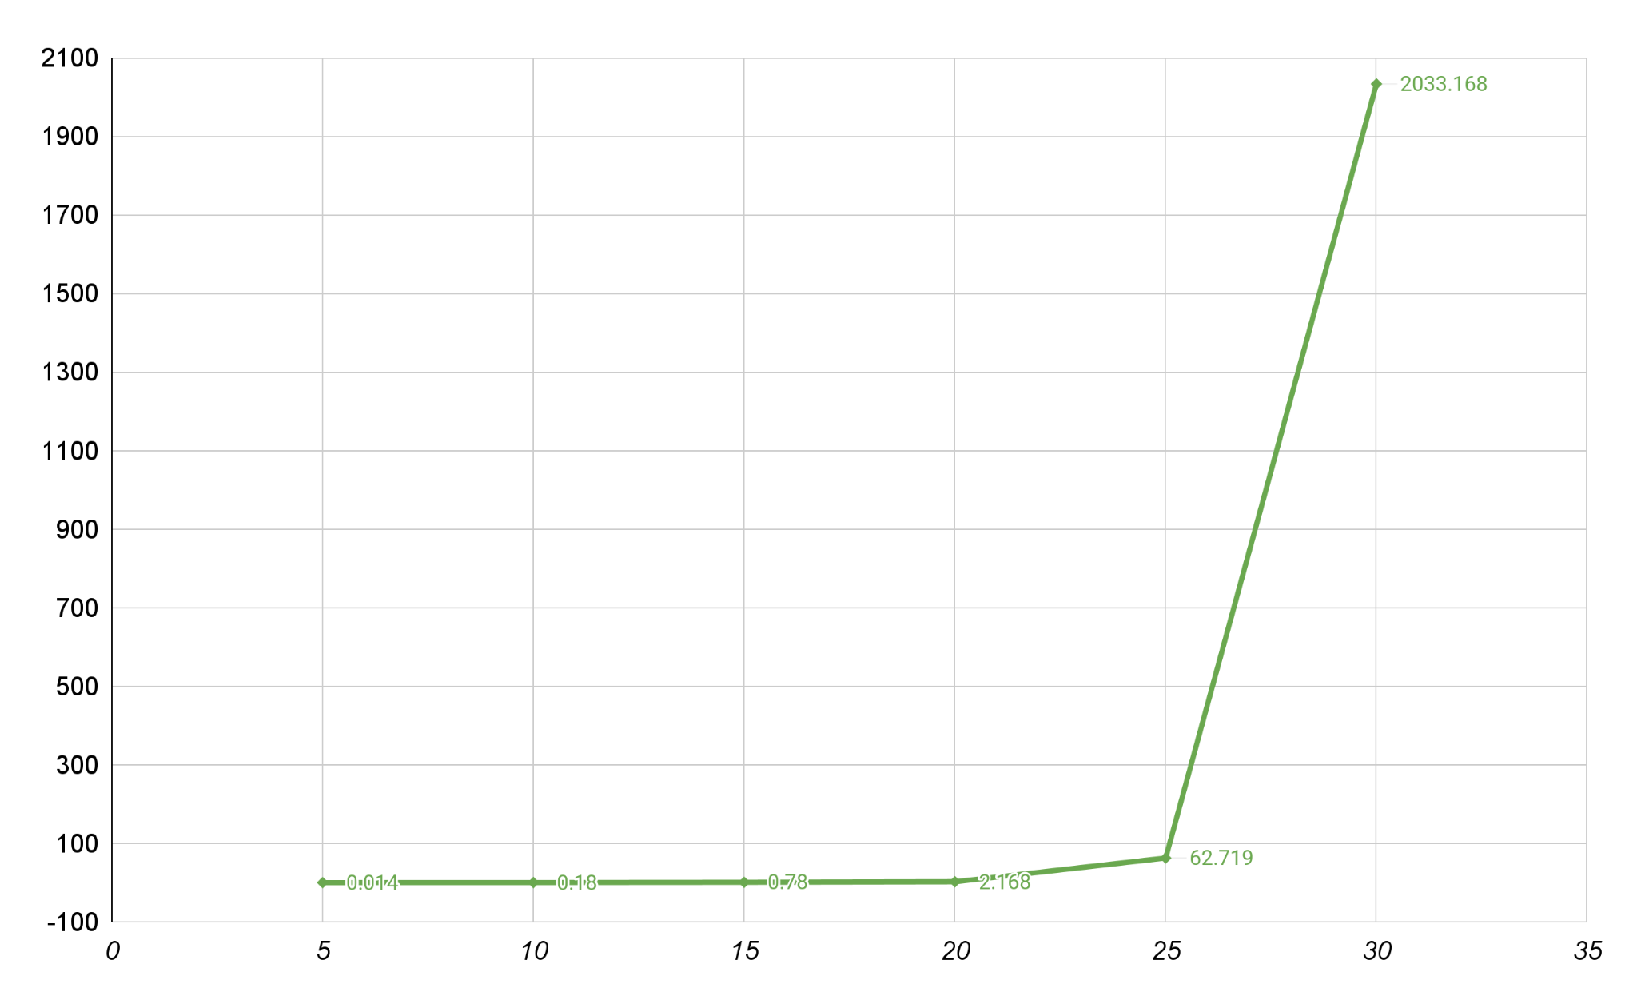

Question 3: Conclusions

1)The the time needed for a solution increases exponentially as the size of the problem increases
2)Whenever the size of the problem increases by one, the time needed for a solution approximately doubles. This approximation gets more and more accurate the bigger the problem gets.
We conclude therefore that the time complexity for this program is exponential O(2^n)

